Project Scope and Plan – Regular Access

Project name | Towards foundation models for 3D semantic occupancy prediction
Research field | PE6 Computer Science and Informatics

Principal Investigator (PI)
Title (Dr., Prof., etc.) | Dr.
First (given) name | Anh-Quan
Last (family) name | Cao
Organisation name | Valeo
Department | CDV
Group | valeo.ai
Country | France

Co-PIs/Team members (same information)
Provide the details of any Co-PIs and Team members in the project, including Title, First (given) name, Last (family) name, Organisation, Department, Group and Country.
Co-Principal Investigator (Co-PI)/Team member
Title (Dr., Prof., etc.) | Dr.
First (given) name | Tuan-Hung
Last (family) name | Vu
Organisation name | Valeo
Department | CDV
Group | valeo.ai
Country | France

Key scientific/societal/technological contribution of the proposal (200 words max.)
This project aims to develop foundation models for 3D semantic occupancy prediction in-the-wild using unposed images/videos. This task infers dense 3D geometry and semantic understanding from 2D images or partial 3D inputs like LiDAR or RGBD scans. Such 3D understanding is crucial for agents to navigate and interact with their environment, particularly in autonomous driving – our main focus. Current state-of-the-art approaches train on semantically labeled 3D LiDAR data which are expensive to acquire and annotate, thus resulting in datasets of limited scale, which constrains model generalization. To address this, we extend the recent geometry foundation model Dust3r [Wang 2024], which introduces a novel pointmap prediction paradigm, demonstrating strong generalization through large-scale training. Yet, it has limited exposure to driving scenarios. Furthermore, it is non-trivial to use Dust3r for occupancy prediction. Thus, our goal is to explore how to extend Dust3r for 3D occupancy prediction, particularly in driving scenarios, by developing new algorithms, incorporating semantic understanding, and leveraging large-scale driving datasets. We further employ supervised and unsupervised learning to improve performance and generalizability. The requested computational resources will support this extensive training process. The resulting models will be open-sourced, contributing to the automotive industry and computer vision research community.

- Detailed proposal information (Maximum 8 pages, graphs and tables included)
  - Justification for the importance of the scientific problem and the requested resources (1 page)
Why 3D semantic occupancy prediction. 3D semantic occupancy prediction is crucial to artificial perception systems given that our physical world exists in three dimensions, requiring comprehensive understanding of both geometric structures and semantic properties for effective interaction. Geometric understanding enables navigation and spatial reasoning, while semantic understanding provides critical context about object identity and scene composition. This dual understanding powers applications ranging from robotic manipulation and augmented reality to autonomous vehicle safety systems, where accurate 3D environment modeling is crucial for obstacle avoidance and trajectory planning. Despite humans' innate 3D perception abilities acquired through evolution, machines continue to struggle with this task - a challenge evidenced by decades of computer vision research from Roberts' early 3D object recognition systems [Roberts 1963] to modern deep learning approaches [Nie 2020].
The need for 3D semantic scene modeling from images. A common method for obtaining 3D geometry and semantics in mobile robotics involves un-projecting estimated 2D semantics [Ravi 2025] into 3D using 2D depth [Yang 2022, Ke 2024]. However, this approach inherently limits the 3D prediction to the visible surfaces. Predicting beyond the visible surface – i.e., reconstructing the complete scene geometry and semantics – would enhance context-rich downstream robotic applications such as planning and motion forecasting. To tackle this challenge, Semantic Scene Completion (SSC) [Song 2017] takes a partial 3D depth or LiDAR scan as input and predicts the complete 3D semantic scene, particularly including occluded areas. Yet, SSC methods require LiDAR or depth input, necessitating specialized sensor setups, which can be costly and cumbersome to install. MonoScene [Cao 2022] extends SSC to a camera-only setting, broadening its applicability to scenarios where only visual data is available. This task, also referred to as 3D semantic occupancy prediction, has recently gained significant attention in autonomous driving, where the need to rely on cameras for cost reduction aligns with the goal of modeling a complete 3D semantic scene from images. This provides critical information for downstream decision-making applications, ultimately improving system safety.
Towards 3D semantic occupancy foundation model. Most state-of-the-art 3D occupancy prediction methods [Zhang 2023, Yu 2024] rely on 3D ground-truth data derived from accumulated LiDAR point clouds. However, collecting and annotating these LiDAR datasets is expensive, which limits their size. For instance, the largest available occupancy dataset, Occ3D-Waymo [Tian 2023], contains around 200,000 frames – significantly fewer than image datasets, which often encompass millions or even billions of samples [Schuhmann 2022]. While there has been work on self-supervised occupancy prediction [Huang 2023], its performance still lags behind that of fully supervised 3D methods. Moreover, [Cao 2022] have shown that 3D occupancy prediction approaches trained on single-domain datasets do not generalize well to in-the-wild scenarios, partly due to the sensor-dependency and limited scale inherent in current datasets. In this work, we aim to develop a foundation model for 3D semantic occupancy prediction from images that generalizes effectively to in-the-wild data. To achieve this, we build upon Dust3r [Wang 2024] and its dynamic scene extension Monst3r [Zhang 2025]. Dust3r is a recently introduced 3D foundation model that has demonstrated remarkable generalization capabilities. Its core approach involves training on a point map regression task using a diverse mix of synthetic and real-world datasets. By addressing the point map regression problem, Dust3r is capable of performing a variety of 3D tasks, including pose estimation, camera calibration, visual localization, and 3D reconstruction. We aim to significantly extend Dust3r to address the task of 3D semantic occupancy prediction for autonomous driving. Our core contributions include: (1) Initial supervised training on a comprehensive suite of large-scale autonomous driving datasets. (2) A novel algorithm specifically designed for predicting 3D semantic occupancy. (3) A knowledge distillation pipeline to effectively transfer semantic knowledge from pre-trained 2D foundation models into our 3D predictor. (4) A self-supervised learning strategy leveraging vast, unlabeled YouTube video datasets to significantly enhance the model's generalization capabilities and performance in unseen environments.

  - Overview of the project (2 pages)
1.2.1 Architecture.
We built upon the elegant design of the Dust3r model family [Wang 2024], pioneered a data-driven approach to geometry understanding, directly regressing dense point maps and camera poses from unposed images after training on diverse, large-scale datasets. This capability to produce geometric outputs directly from images provides a foundation for 3D tasks, including pose estimation, depth recovery, and 3D reconstruction. Building upon this foundation, follow-up works [Leroy 2024, Zhang 2025, Yang 2025, Wang 2025] have proposed various strategies to improve Dust3r's efficiency, targeting aspects like inference speed and memory usage.
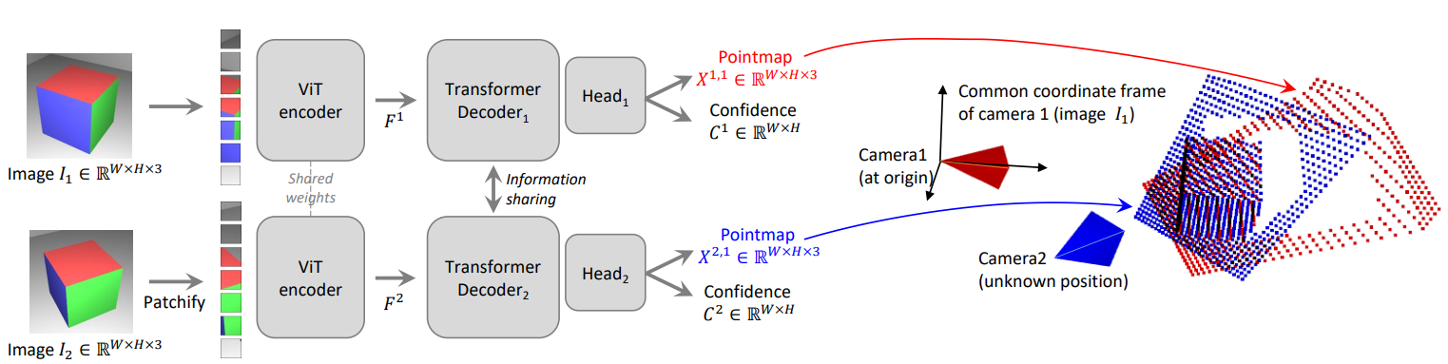
Figure 1: Dust3r architecture

We enhance Dust3r’s architecture by incorporating a semantic head that generates rich semantic features, facilitating the construction of the final occupancy map by seamlessly integrating Dust3r’s geometry predictions with the semantic outputs. At the core of the model are transformer blocks that exchange information across both local patches and different viewpoints, enabling accurate geometric mapping and consistent semantic predictions.

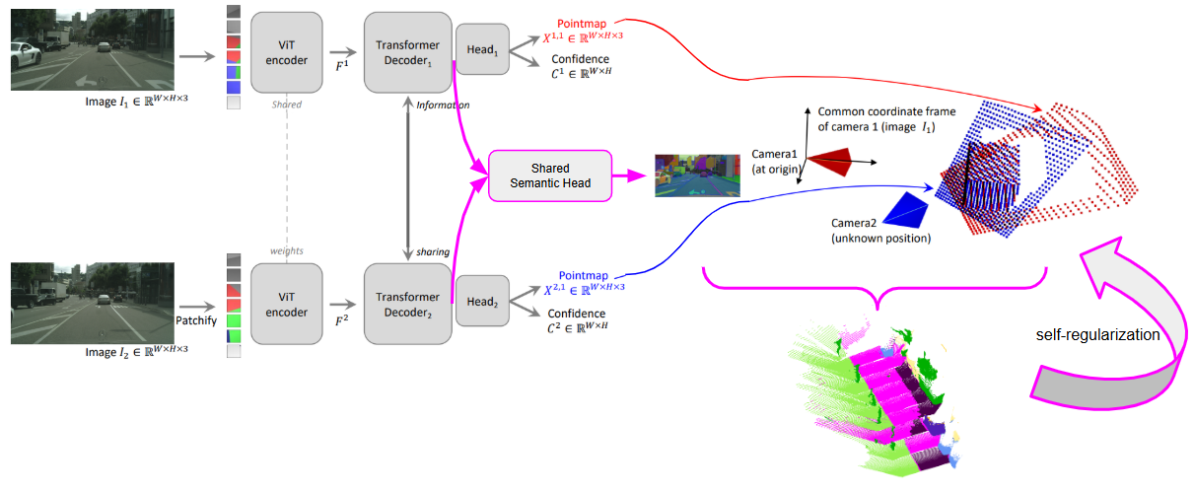
Figure 2: Our proposed architecture for occupancy prediction in autonomous driving

Our training is done on autonomous driving datasets that exhibit large-scale cluttered scenes with many dynamic objects. We thus devise different strategies to handle dynamicity by estimating the dynamic mask by localizing areas of high motions [Zhang 2025]. To accommodate semantics, we investigate different strategies (SAM2 [Ravi 2025], DINOv2 [Oquab 2024]) and redesign the downstream architecture to make seamless the interaction between semantic and geometry head [Lopes 2023], targeting a holistic network that can derive geometrical and semantic understandings in a consistent way. We then investigate various algorithms for robust extraction of 3D semantic occupancy from the resulting semantic pointmaps. In pursuit of highly generalizable foundation models, we scale training across large-scale driving datasets collected with diverse sensor suites. As an exploratory direction, we also extend training to unposed, unlabeled datasets captured in the wild, such as public driving videos from YouTube [Yang 2024].
1.2.2. Training strategy
We will separate the training of this architecture in three phases:
- Phase A – Geometry Pre-training: Pre-train Monst3r on autonomous driving datasets with geometry loss to learn robust geometric representations.
- Phase B – Semantic Distillation: Distill semantic features from 2D foundation models (e.g., DINOv2 [Oquab 2024], SAM2 [Ravi 2025]) into the geometry-pretrained model from Phase A, enriching it with high-level visual semantics.
- Phase C – Large-scale Self-training: Use the model from Phase B to generate geometry pseudo-labels on a large-scale YouTube video dataset [Yang 2024]. Then, perform self-training using these pseudo-labels, combining both geometry loss and semantic distillation to further enhance the model's performance.
Phase A – Geometry Pre-training. We plan to pre-train the model on collection of images-lidar datasets where LiDAR can provide geometry ground-truth for supervision. We combine public available datasets such as waymo open dataset [Ettinger 2021] with 390k sensor frames, DDAD [Guizilini 2020] with 17k sensor frames, Argoverse2 [Wilson 2021] with 150k sensor frames and PandaSet [Xiao 2021] with 16k sensors frames. Each sensor frame includes at least one LiDAR and multiple cameras. This pre-training step provides a good foundation geometric representation for Phase B. Due to the inherent domain gaps between different datasets, we revisit some domain adaptation techniques developed by the co-PIs [Vu 2019] to facilitate training on multiple domains.
Phase B – Semantic Distillation. In this phase, we enhance the model trained in Phase A by extending its architecture to predict dense semantic features, as detailed in Section 2.2.1. We train this newly added semantic head by distilling knowledge from 2D foundation models such as DINOv2 and SAM2. To ensure the preservation of the geometric representations learned in Phase A, we continue to apply the same geometry loss alongside the semantic supervision. We leverage techniques developed by the PIs [Cao 2022, Cao 2023, Cao 2024] to derive occupancy predictions from geometric and semantic outputs.
Phase C – Large-scale Self-training. We leverage the model from Phase B to generate pseudo-labels on unposed, unlabeled datasets captured in the wild – such as the OpenDV dataset [Yang 2024], which contains 1,700 hours of real-world public driving videos. By self-training on this large-scale dataset, we aim to improve the model’s ability to generalize across diverse real-world scenes. In this phase, we explore different strategies for self-training while preserving the semantic and geometric representations learned in Phase B.
1.2.3 Outcome and impact
The outcome of this project will yield a versatile foundation 3D semantic occupancy prediction model that offers exhaustive understanding of urban scenes across diverse driving environments. The model serves as a core component for downstream control tasks that require joint geometric and semantic reasoning to accurately forecast agent behavior and inform driving decisions.

  - Validation, verification, state of the art (1 page)
    - Validation & Verification
The architecture builds on top of the published works: Dust3r [Wang 2024], Monst3r [Zhang 2025], Mast3r [Leroy 2024] and SAM2 [Ravi 2025]. To accommodate the new task of occupancy prediction, we propose new architectural design and training schemes inspired by the PIs [Cao 2022, Cao 2023]. We also devise new strategies to encourage synergic interactions between geometric and semantic heads. The code of these methods are public, which ensure reproducibility:
- Dust3r: https://github.com/naver/dust3r
- Monst3r: https://github.com/Junyi42/monst3r/
- Mast3r: https://github.com/naver/mast3r
- Segment Anything: https://github.com/facebookresearch/sam2
- MonoScene (PIs’ work): https://github.com/astra-vision/MonoScene
- PaSCo (PIs’ work): https://github.com/astra-vision/PaSCo
For training, we leverage existing synthetic and real datasets for autonomous driving:
- Waymo Open Dataset [Ettinger 2021]: ~390k sensor frames (5 LiDARs + 5 cameras)
- DDAD [Guizilini 2020]: ~17k sensor frames (4 LiDARs + 5 cameras).
- Argoverse 2 [Wilson 2021]: ~150k sensor frames (2 LiDARs + 7 cameras).
- PandaSet [Xiao 2021]: ~16k sensor frames (2 LiDARs + 6 cameras).
- Virtual Kitti 2 [Cabon 2020]: ~22k sensor frames (1 LiDAR + 2 cameras).
- OpenDV [Yang 2024]: ~ 1700 hours of driving video.
Thanks to the release of these codes and datasets, we can verify the scaling law for the occupancy prediction models and for the first time train the model with such a scale of diverse driving scenes.
    - Comparison with state of the art
In occupancy prediction, existing approaches face a critical limitation due to their reliance on precisely calibrated sensor setups, requiring full a priori knowledge of camera intrinsic and extrinsic parameters. This constraint not only restricts the scale of available occupancy datasets but also creates sensor-specific dependencies, limiting model generalizability as they typically require calibration information and are thus trained on specific sensor suites. Our approach leverages a more generic paradigm – pointmap prediction – which eliminates calibration constraints while maintaining simplicity, enabling us to scale training across vast collections of diverse labeled and unlabeled datasets captured using various sensors, including public YouTube videos. To our knowledge, we are the first to address occupancy prediction at this scale and investigate its scaling laws, making this work both original and impactful for the automotive domain's academic and industrial communities, particularly in handling unposed and uncalibrated camera inputs.
  - Software and Attributes (1 page)
    - Software
As mentioned above, this project relies on codes which are publicly available:
- Dust3r: https://github.com/naver/dust3r
- Monst3r: https://github.com/Junyi42/monst3r/
- Mast3r: https://github.com/naver/mast3r
- Segment Anything: https://github.com/facebookresearch/sam2
- MonoScene (PIs’ work): https://github.com/astra-vision/MonoScene
- PaSCo (PIs’ work): https://github.com/astra-vision/PaSCo
The PIs are domain experts with strong familiarity in this area.

    - Particular libraries
We leverage the PyTorch and Torchrun libraries for efficient training and inference on GPUs.
    - Parallel programming
The training of the deep neural networks is done on one or several nodes of multiple NVIDIA GPUs. The distribution of the computations is handled by well-optimised libraries of PyTorch and Torchrun.
The codes we rely upon have already been tested on one or multiple nodes internally at Valeo (NVIDIA V100, A100 and H100), on the French supercomputer Jean-Zay (NVIDIA V100 and H100).
The PIs and co-PIs have strong experience training models on supercomputers (Jean-Zay in France and EuroHPC Karolina) in different development/regular calls.
    - I/O requirements
There’s no specific bottleneck from I/O for training our models, yet data needs to be accessed fast enough during training as they are continuously loaded from disk: 10 MB/s/gpu, i.e., 80 MB/s/node. Up to 10M files (binary file, jpeg, png, etc) for the largest datasets.
  - Data: Management Plan, Storage, Analysis and Visualization (~1 page)
    - Data Management Plan covering
We mostly re-use public datasets available online. We will train models on existing publicly available datasets, such as Waymo Open Dataset, DDAD, Argoverse 2, PandaSet, Virtual Kitti 2 datasets.
We use image files (e.g., .jpg, .png) as inputs to the model and LiDAR point clouds (.bin) as geometry ground-truth for supervision. The trained models are saved in framework-specific formats – for example, .pth files for the PyTorch framework. Dataset sizes range from tens of gigabytes to several terabytes, while only a few gigabytes are required to store the trained AI models.
We will credit EuroHPC for the data and results produced through this allocation when publishing, and describe the allocation in the provenance when depositing them to other infrastructures.
The potential users of this application case are in the computer vision and machine learning scientific and industrial community, with a focus on automotive applications.
    - Project workflow
The project is structured into three key phases: (1) Geometry pre-training utilizing established autonomous driving datasets to establish robust 3D geometry understanding; (2) Semantic distillation through integration of 2D foundation models (e.g., SAM2) to enhance scene comprehension and feature representation; (3) Self-training refinement using high-quality pseudo-labels generated from extensive real-world driving data. Throughout the development process, we systematically investigate architectural innovations and training strategies to optimize geometric accuracy, semantic understanding, and computational efficiency, while maintaining scalability across diverse driving scenarios.
    - Software workflow solution
The codes we rely upon already include dataloaders running in parallel on multiple CPUs (the distribution of the computation is fully handled by PyTorch) and ensures that the data are provided at a high enough rate for a maximum GPU usage.
    - I/O requirements
Trained models are saved as PyTorch files of a few gigabytes, but only the best performers, identified via metrics, will be downloaded locally to manage storage. Performance metrics are logged using TensorBoard (https://www.tensorflow.org/tensorboard), producing log files of a few megabytes accessible remotely or locally. To address the limit of maximum number of files in current I/O systems, image and point cloud data are compressed into ZIP archives and read on the fly during training.
  - Performance of Software (Maximum 2 pages)
    - Testing of your code on the requested machine
We did not test our codes on the specific requested machines. Yet, these codes have been running in different GPU clusters with similar infrastructure without any issue: e.g., on Jeanzay HPC using V100/H100 GPUs in a smaller scale (due to limited GPU hours), highlighting the portability of the code thanks to PyTorch and Torchrun.
    - Quantify the HPC performance of your project

Strong and weak scalability
Table 1 and Figure 3 present the strong and weak scalability performance of our method, measured during tiny-scale training (3000 items per epoch). For comparison, our standard training process uses 60,000 items per epoch (10,000 per dataset). Training benefits significantly from larger batch sizes, which allow for a more accurate estimation of the loss function's gradient and ultimately improve final model performance. Conversely, using a small batch size (e.g., 32 LiDAR-image pairs distributed across 4 GPUs), while technically feasible, leads to inefficiently long training times and degraded results.
Table 1: Scalability Metrics (Strong vs. Weak)
Estimated with 3,000 items/epoch on a single 4xH100 GPU node on Jean-Zay supercomputer.
 | GPUs | Total Batch Size | Batch/GPU | Training Time/Epoch (s) | Speedup (vs. 1 GPU) | Efficiency (%)
Strong Scalability | 1 | 8 | 8 | 213 | 1x | 100
 | 2 | 8 | 4 | 138 | 1.54x | 77
 | 4 | 8 | 2 | 89 | 2.39x | 60
Weak Scalability | 1 | 8 | 8 | 213 | 1x | 100
 | 2 | 16 | 8 | 124 | 1.72x | 86
 | 4 | 32 | 8 | 70 | 3.04x | 76

Figure 3: Scalability Metrics (Strong vs. Weak)
Estimated with 3,000 items/epoch on a single 4xH100 GPU node on Jean-Zay supercomputer.
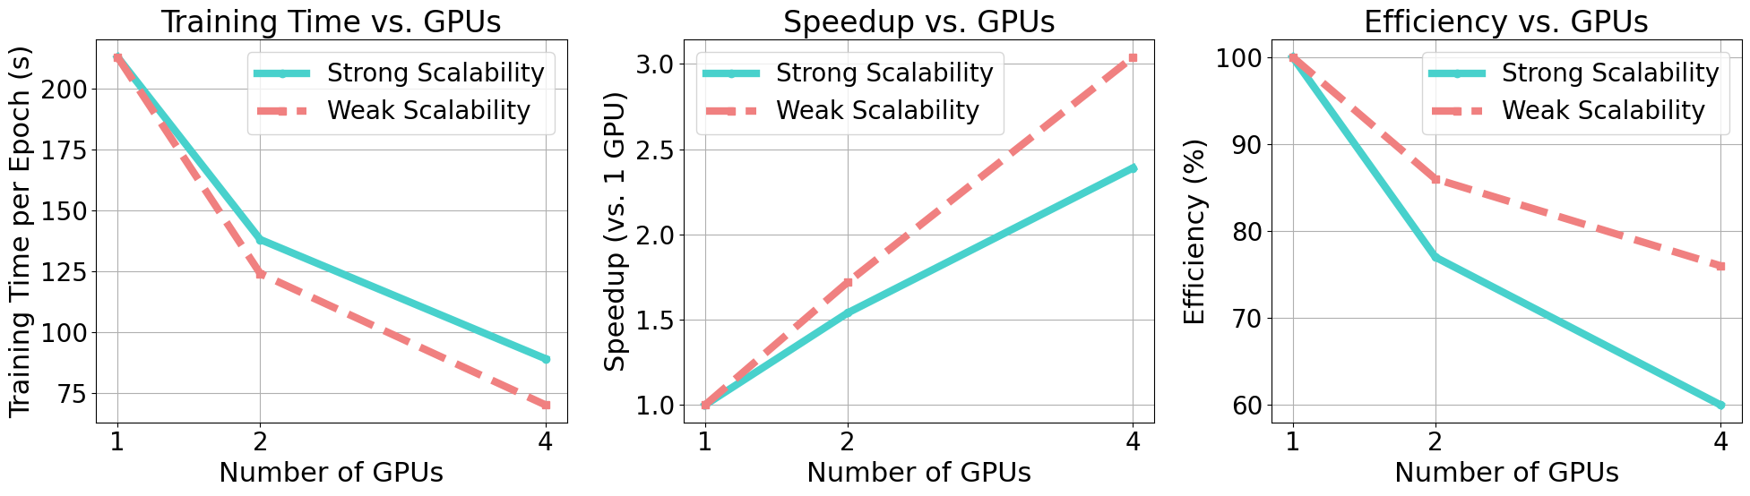
In the context of our project, we prioritize configurations that can run efficiently on a single node, enabling rapid experimentation and hyperparameter tuning across multiple configurations during the development phases. This single-node approach allows for more thorough exploration of the parameter space. After identifying the optimal configuration through iterative experimentation, we will scale up to multi-node training for the final model. This strategy ensures efficiency during development while maximizing the performance of the production model.

Precision reported
Our models are trained using mixed precision, handled by PyTorch.

Time-to-solution
Usual training times vary from 3 days to 1 week for the final model. Checkpointing strategy is implemented to ensure that the model training can be recovered after interruption (e.g., walltime).

System scale
By relying on PyTorch and Torchrun which handles the distribution of the computations, it is easy to scale the computations on multiple nodes. However it is for the moment hard to predict the final performance of the final trained model a priori beyond the usual observation that longer training and large batch size often leads to better performance.

Measurement mechanism
Pytorch profiling tools will be used.

Memory usage
We manage the memory usage through careful configuration of two key parameters: batch size and data loading workers. The batch size is dynamically adjusted to fully utilize GPU memory capacity while preventing out-of-memory errors, ensuring efficient hardware utilization. Simultaneously, the number of data loading workers is optimized to balance RAM consumption with data throughput, preventing system memory overload while maintaining sufficient data pipeline performance. This dual-parameter approach allows for efficient resource utilization across both GPU and CPU/RAM, enabling stable training with maximum hardware efficiency.
- Milestones (quarterly basis) (Maximum 1 page)
Run Type | Code(s) | No. of runs | No. of nodes | No. of steps per run | No. of cores per node | Time per step(s) | Total node hours
Phase A – Geometry Pre-training | Monst3r | 60 | 4 | 93750 | 8 | 0.8 | 5000
Phase B – Semantic Distillation | Ours (Monst3r + Occ) | 60 | 4 | 93750 | 8 | 0.8 | 5000
Phase C – Large-scale Self-training | Ours (Monst3r + Occ) | 120 | 4 | 93750 | 8 | 0.8 | 10000
Phase D Adapting on private data | Ours (Monst3r + Occ) | 60 | 4 | 93750 | 8 | 0.8 | 5000

  - Gantt Chart
Task | Month 1 | Month 2 | Month 3 | Month 4 | Month 5 | Month 6 | Month 7 | Month 8 | Month 9 | Month 10 | Month 11 | Month 12
Optim. architecture
Phase A – Geometry Pre-training
Phase B – Semantic Distillation
Phase C – Large-scale Self-training
Phase D Adapting on private data
Result collection and analysis

- Personnel and Management Plan (0,5 page)
The core development team for this project comprises Anh-Quan, a Research Scientist, and Tuan-Hung, a Senior Research Scientist. Both are based at valeo.ai in Paris, France, and have a history of successful collaboration.
To achieve the project's objectives, Anh-Quan will concentrate on algorithm development and semantic distillation, utilizing the monst3r codebase and preparing datasets from Waymo, DDAD, and Virtual Kitti. Tuan-Hung will guide the project strategy and prepare data for PandaSet, Argoverse 2, and OpenDV. They will jointly conduct experiments, potentially focusing on distinct aspects such as optimizing architecture design and refining learning strategies.
The project can be scaled up with support from the EXA4MIND project at valeo.ai, including resources and personnel such as David Hurych.
- References (Maximum 30)
[Wang 2024] Wang et al. DUSt3R: Geometric 3D Vision Made Easy. CVPR 2024.
[Roberts 1963] Roberts. Machine perception of three-dimensional solids. PhD thesis, MIT, 1963.
[Nie 2020] Nie et al. Total3dunderstanding: Joint layout, object pose and mesh reconstruction for indoor scenes from a single image. CVPR 2020.
[Yang 2024] Yang et al. Depth Anything V2. NeurIPS 2024.
[Cao 2022] Cao et al. MonoScene: Monocular 3D Semantic Scene Completion. CVPR 2022.
[Cao 2023] Cao et al. SceneRF: Self-Supervised Monocular 3D Scene Reconstruction with Radiance Fields. ICCV 2023.
[Ke 2024] Ke et al. Marigold: Repurposing Diffusion-Based Image Generators for Monocular Depth Estimation. CVPR 2024.
[Ravi 2025] Ravi et al. SAM 2: Segment Anything in Images and Videos. ICLR 2025.
[Yu 2024] Yu et al. Context and Geometry Aware Voxel Transformer for Semantic Scene Completion. NeurIPS 2024.
[Zhang 2023] Zhang et al. OccFormer: Dual-path Transformer for Vision-based 3D Semantic Occupancy Prediction. ICCV 2023.
[Tian 2023] Tian et al. Occ3D: A Large-Scale 3D Occupancy Prediction Benchmark for Autonomous Driving. NeurIPS 2023.
[Schuhmann 2022] Schuhmann et al. LAION-5B: An open large-scale dataset for training next generation image-text models. NeurIPS 2022.
[Huang 2023] Huang et al. SelfOcc: Self-Supervised Vision-Based 3D Occupancy Prediction. CVPR 2023.
[Zhang 2025] Zhang et al. MonST3R: A Simple Approach for Estimating Geometry in the Presence of Motion. ICLR 2025.
[Yang 2025] Yang et al. Fast3R: Towards 3D Reconstruction of 1000+ Images in One Forward Pass. CVPR 2025.
[Wang 2025] Wang et al. Continuous 3D Perception Model with Persistent State. CVPR 2025.
[Leroy 2024] Leroy et al. Grounding Image Matching in 3D with MASt3R. ECCV 2024.
[Lopes 2023] Lopes et al. Cross-task Attention Mechanism for Dense Multi-task Learning. WACV 2023.
[Oquab 2024] Oquab et al. DINOv2: Learning Robust Visual Features without Supervision. TMLR 2024.
[Yang 2024] Yang et al. Generalized Predictive Model for Autonomous Driving. CVPR 2024.
[Wilson 2021] Wilson et al. Argoverse 2: Next Generation Datasets for Self-driving Perception and Forecasting. NeurIPS 2021.
[Xiao 2021] Xiao et al. PandaSet: Advanced Sensor Suite Dataset for Autonomous Driving. ITSC 2021.
[Cabon 2020] Cabon et al. Virtual KITTI 2. arXiv 2020.
[Song 2017] Song et al. Semantic Scene Completion from a Single Depth Image. CVPR 2017.
[Vu 2019] Vu et al. ADVENT: Adversarial Entropy Minimization for Domain Adaptation in Semantic Segmentation. CVPR 2019.
[Guizilini 2020] Guizilini et al. 3D Packing for Self-Supervised Monocular Depth Estimation. CVPR 2020.

- Confidentiality (0,5 page)
- Is any part of the project covered by confidentiality? no
Most of the experiments will be conducted on the public datasets: Waymo Open Dataset [Ettinger 2021], DDAD [Guizilini 2020] PandaSet [Xiao 2021], Argoverse 2 [Wilson 2021], Virtual Kitti 2 [Cabon 2020], and OpenDV [Yang 2024].
While Valeo proprietary data may be utilized in Phase D, all associated results, along with the corresponding code, will be made publicly available to ensure transparency and reproducibility of the research findings.
- Does your project involve handling of personal data? no
All data is preprocessed (anonymization) to respect the General Data Protection Regulation.

